**LEBANESE AMERICAN UNIVERSITY**

**USAID – HIGHER EDUCATION SCHOLARSHIP PROGRAM**

**HES - Volunteering Program Verification Form**

This form is to be used to document volunteering hours. If a student volunteers for multiple organizations, a separate form must be used for each organization. **This form must be turned in by the 28th of each month, the latest.**

I certify that the scholar Bader Ammar Houram completed a total of 6 hours of service at Life Sculptor.

The hours were completed hours as per the below:

Hours # 2 (date) _02/09 - 06/09_ (initials of supervisor) __A.K.___

Hours # 2 (date) _09/09 – 13/09_ (initials of supervisor) __A.K.___

Hours # 2 date) _16/09 – 20/09 (initials of supervisor) __A.K.___

Hours # 0 date) _23/09 – 27/09 (initials of supervisor) __A.K.___

Brief description of the activities the scholar performed or participated in:

I performed a research task on the following: Introduction to Parenting Styles  
Overview of Different Parenting Styles (Authoritative, Authoritarian, Permissive, Uninvolved)  
Impact of Parenting Styles on Children's Physical Health  
Influence of Parenting Styles on Children's Mental Health  
Role of Parenting in Shaping Health Behaviors  
Cultural Considerations in Parenting Styles and Health  
Long-Term Effects of Parenting Styles on Health Outcomes  
Conclusion and Implications for Parenting Practices

Written feedback about the scholar’s performance:

Bader Houran conducted comprehensive research on various parenting styles, exploring their impact on children's physical and mental health, along with cultural considerations. His analysis highlights the long-term effects of these styles, showcasing his ability to evaluate complex relationships between parenting and health outcomes.

Please rate the overall performance of the scholar at your organization:

|  |  |  |  |
| --- | --- | --- | --- |
|  | Mastery (5) | Proficient (3) | Emerging (1) |
| **Problem solver** | X |  |  |
| **Engaged & Committed** | X |  |  |
| **Open-minded & multicultural** | X |  |  |

Signature

& stamp

__________________________

_

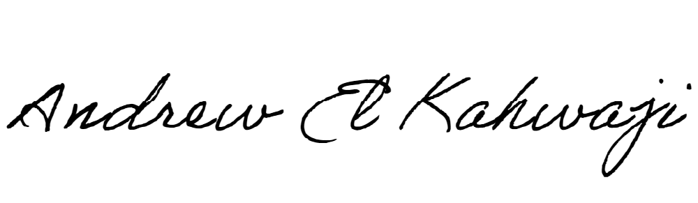

Printed Name _Andrew El Kahwaji_

Date __25/09/2024___

Email __andrew.lifesculptor.coo@gmail.com __

Phone __+961 71 914 378__

**LEBANESE AMERICAN UNIVERSITY**

**USAID – HIGHER EDUCATION SCHOLARSHIP PROGRAM**

